**TUGAS 2 Praktikum Pemrograman Dasar**

Nama : M Irfan Syarifuddin

NRP : 171111051

Screenshot :

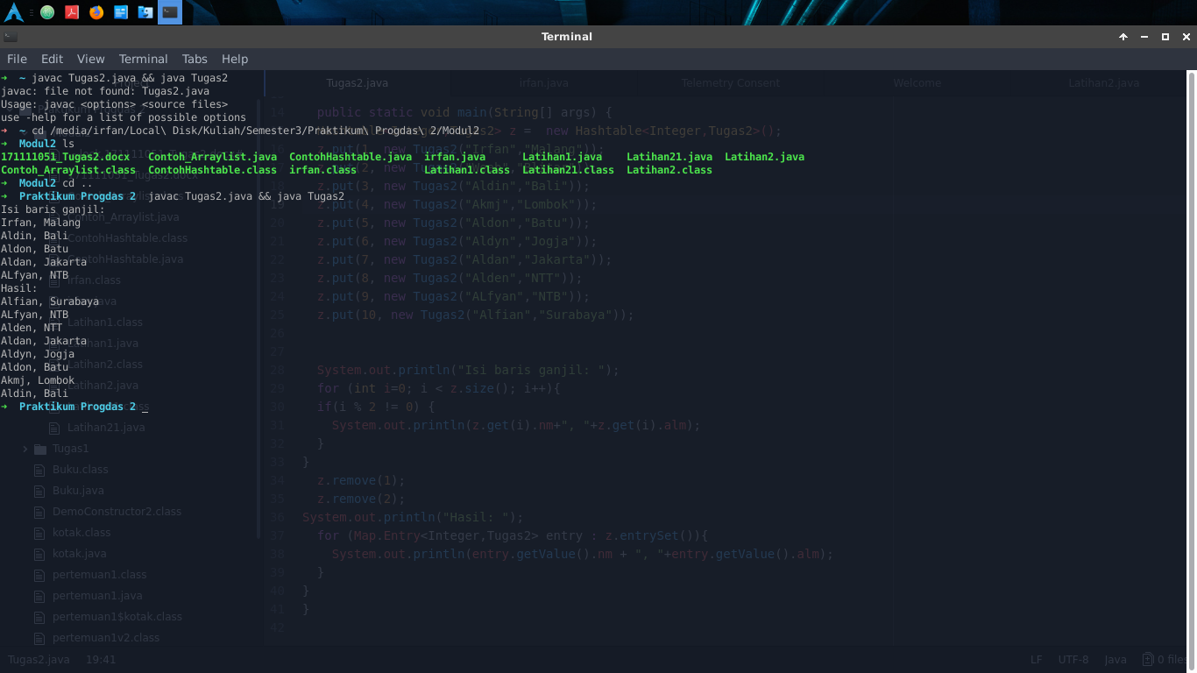

Script :

1. **import** java.util.Hashtable;
2. **import** java.util.Map;
4. **public** **class** Tugas2{
6. String nm ;
7. String alm ;
9. Tugas2 (String a, String b ){
10. nm = a ;
11. alm = b ;
12. }
14. **public** **static** **void** main(String[] args) {
15. Hashtable<Integer,Tugas2> z =  **new** Hashtable<Integer,Tugas2>();
16. z.put(1, **new** Tugas2("Irfan","Malang"));
17. z.put(2, **new** Tugas2("Weeb","Blitar"));
18. z.put(3, **new** Tugas2("Aldin","Bali"));
19. z.put(4, **new** Tugas2("Akmj","Lombok"));
20. z.put(5, **new** Tugas2("Aldon","Batu"));
21. z.put(6, **new** Tugas2("Aldyn","Jogja"));
22. z.put(7, **new** Tugas2("Aldan","Jakarta"));
23. z.put(8, **new** Tugas2("Alden","NTT"));
24. z.put(9, **new** Tugas2("ALfyan","NTB"));
25. z.put(10, **new** Tugas2("Alfian","Surabaya"));

28. System.out.println("Isi baris ganjil: ");
29. **for** (**int** i=0; i < z.size(); i++){
30. **if**(i % 2 != 0) {
31. System.out.println(z.get(i).nm+", "+z.get(i).alm);
32. }
33. }
34. z.remove(1);
35. z.remove(2);
36. System.out.println("Hasil: ");
37. **for** (Map.Entry<Integer,Tugas2> entry : z.entrySet()){
38. System.out.println(entry.getValue().nm + ", "+entry.getValue().alm);
39. }
40. }
41. }